Point in Solid Geometry

Definition
# Source: AI Source: Provided by: [Data Path: Persons Table -> ID Column: 1, Name_En Column: Motasem Essam] -> From: [ChatGPT] on [7/25/2026]
A Point in Solid Geometry is an exact location in three-dimensional space. It has no length, width, height, area, or volume. It indicates position rather than physical size.

Simple Definition
# Source: AI Source: Provided by: [Data Path: Persons Table -> ID Column: 1, Name_En Column: Motasem Essam] -> From: [ChatGPT] on [7/25/2026]
A point is a location in space represented by a dot and usually named with a capital letter, such as $A$, $B$, or $P$.
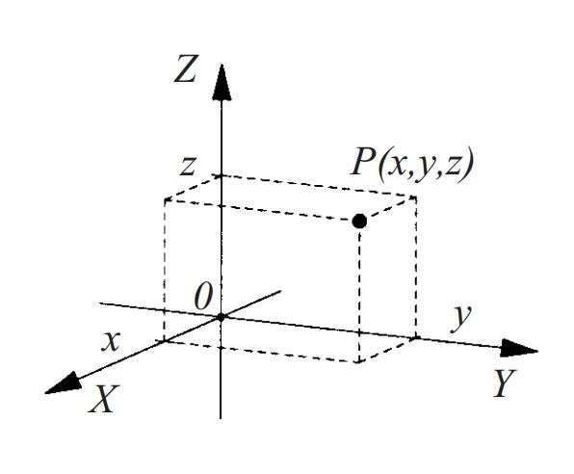
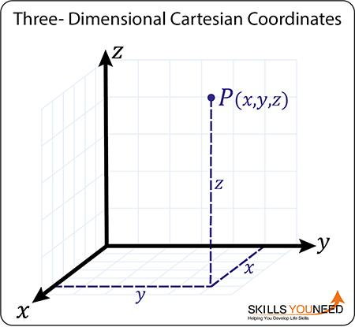
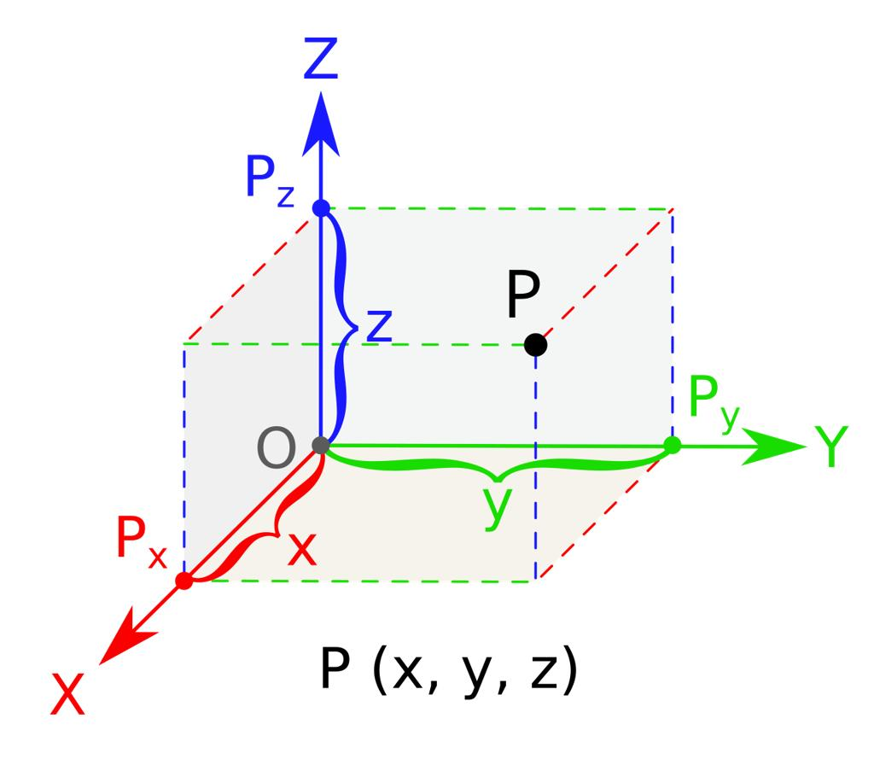

Fundamental Properties
# Source: AI Source: Provided by: [Data Path: Persons Table -> ID Column: 1, Name_En Column: Motasem Essam] -> From: [ChatGPT] on [7/25/2026]
- Dimensionless: A point has no dimensions or physical size.
- Position: It identifies a specific location in space.
- Unique Location: A named point represents one particular location within the geometric model.
- No Shape: A point is not a polygon, solid, or surface.
- Geometric Representation: A dot is used to illustrate a point, but the dot itself has visible size while the mathematical point does not.

Position of a Point in Solid Geometry
# Source: AI Source: Provided by: [Data Path: Persons Table -> ID Column: 1, Name_En Column: Motasem Essam] -> From: [ChatGPT] on [7/25/2026]
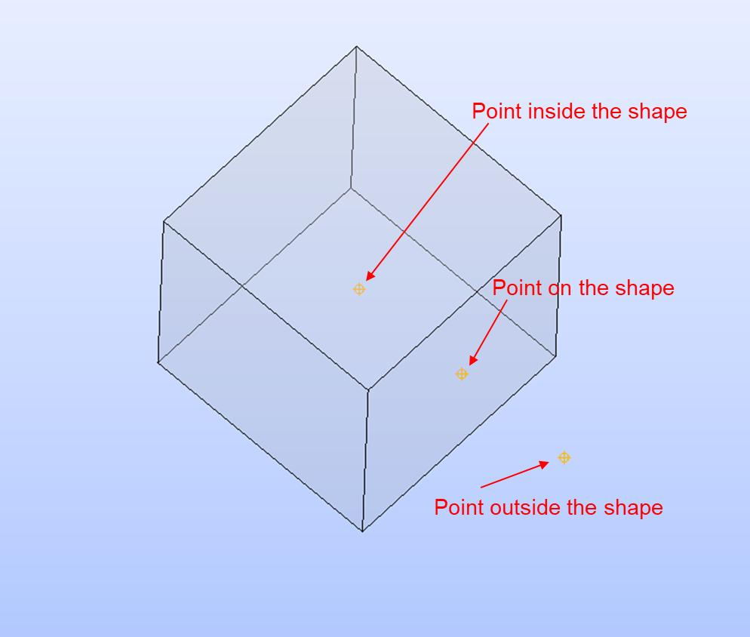
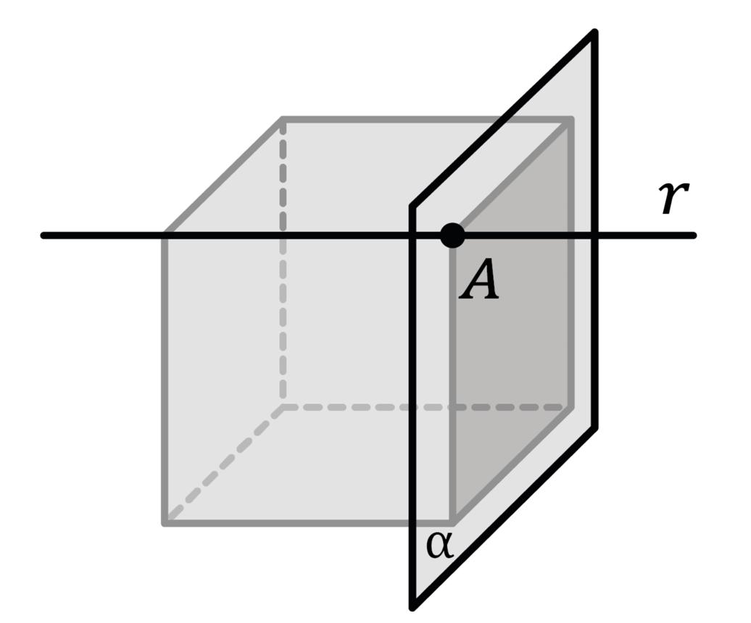
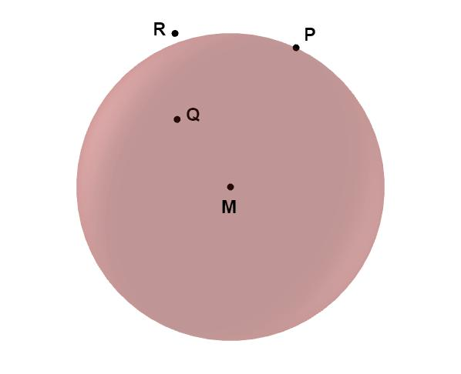
A point can be classified by its position relative to a geometric object.
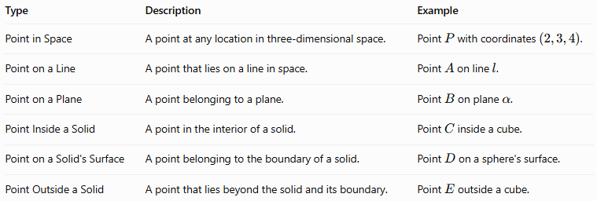
Type | Description | Example
Point in Space | A point at any location in three-dimensional space. | Point $P$ with coordinates $\left(2,3,4\right)$.
Point on a Line | A point that lies on a line in space. | Point $A$ on line $l$.
Point on a Plane | A point belonging to a plane. | Point $B$ on plane $α$.
Point Inside a Solid | A point in the interior of a solid. | Point $C$ inside a cube.
Point on a Solid's Surface | A point belonging to the boundary of a solid. | Point $D$ on a sphere's surface.
Point Outside a Solid | A point that lies beyond the solid and its boundary. | Point $E$ outside a cube.

Coordinates of a Point in Three-Dimensional Space
# Source: AI Source: Provided by: [Data Path: Persons Table -> ID Column: 1, Name_En Column: Motasem Essam] -> From: [ChatGPT] on [7/25/2026]
In three-dimensional Cartesian coordinates, a point is represented by an ordered triple:
$$P=\left(x,y,z\right)$$
Where:
- $x$ represents the position along the $x$-axis.
- $y$ represents the position along the $y$-axis.
- $z$ represents the position along the $z$-axis.
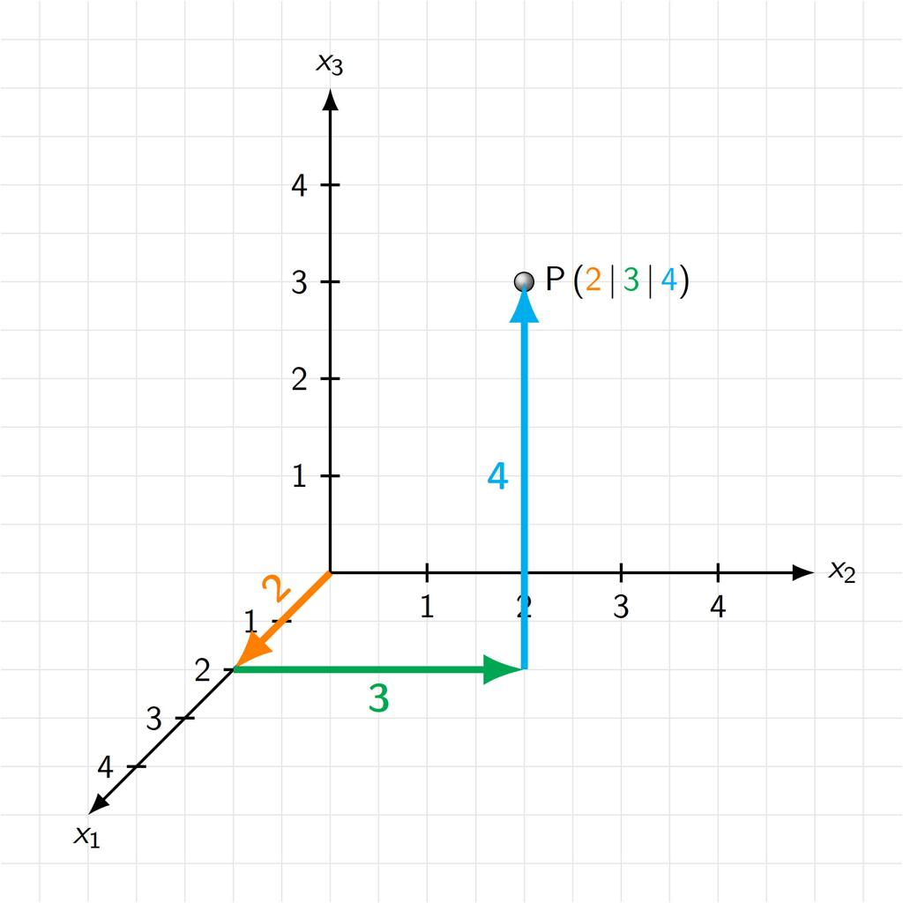
Example:
If point $P=\left(2,3,4\right)$, its coordinates indicate a position 2 units along the $x$-direction, 3 units along the $y$-direction, and 4 units along the $z$-direction from the origin.
The origin is the point
$$O=\left(0,0,0\right)$$

Distance Between Two Points
# Source: AI Source: Provided by: [Data Path: Persons Table -> ID Column: 1, Name_En Column: Motasem Essam] -> From: [ChatGPT] on [7/25/2026]
The distance between two points in three-dimensional Euclidean space is calculated using the three-dimensional distance formula.
For points $P_{1}=\left(x_{1},y_{1},z_{1}\right)$ and $P_{2}=\left(x_{2},y_{2},z_{2}\right)$:
$$d=\sqrt{{\left(x_{2}-x_{1}\right)}^{2}+{\left(y_{2}-y_{1}\right)}^{2}+{\left(z_{2}-z_{1}\right)}^{2}}$$
Example:
Let $A=\left(1,2,3\right)$ and $B=\left(4,6,3\right)$.
$$\begin{aligned}d&=\sqrt{{\left(4-1\right)}^{2}+{\left(6-2\right)}^{2}+{\left(3-3\right)}^{2}} \\ &=\sqrt{9+16+0} \\ &=\sqrt{25} \\ &=5\end{aligned}$$
Therefore, the distance between $A$ and $B$ is 5 units.

Constructing Point in Solid Geometry

Types of Instrument-Based Point Construction Tools

Straightedge
# Source: AI Source: Provided by: [Data Path: Persons Table -> ID Column: 1, Name_En Column: Motasem Essam] -> From: [ChatGPT] on [7/25/2026]
Used to construct straight lines through given points and extend construction lines.
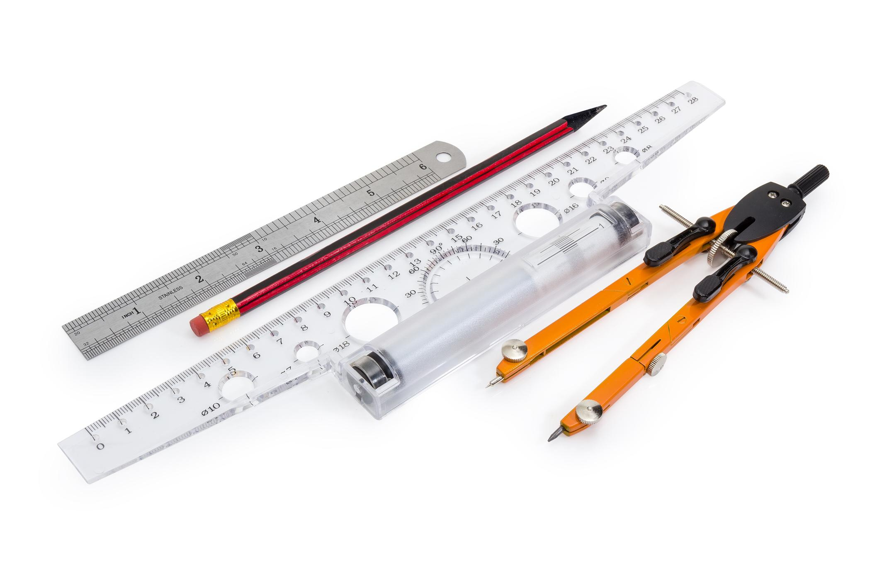

Compass
# Source: AI Source: Provided by: [Data Path: Persons Table -> ID Column: 1, Name_En Column: Motasem Essam] -> From: [ChatGPT] on [7/25/2026]
Used to draw circles and arcs that help determine points at specified distances from a center.
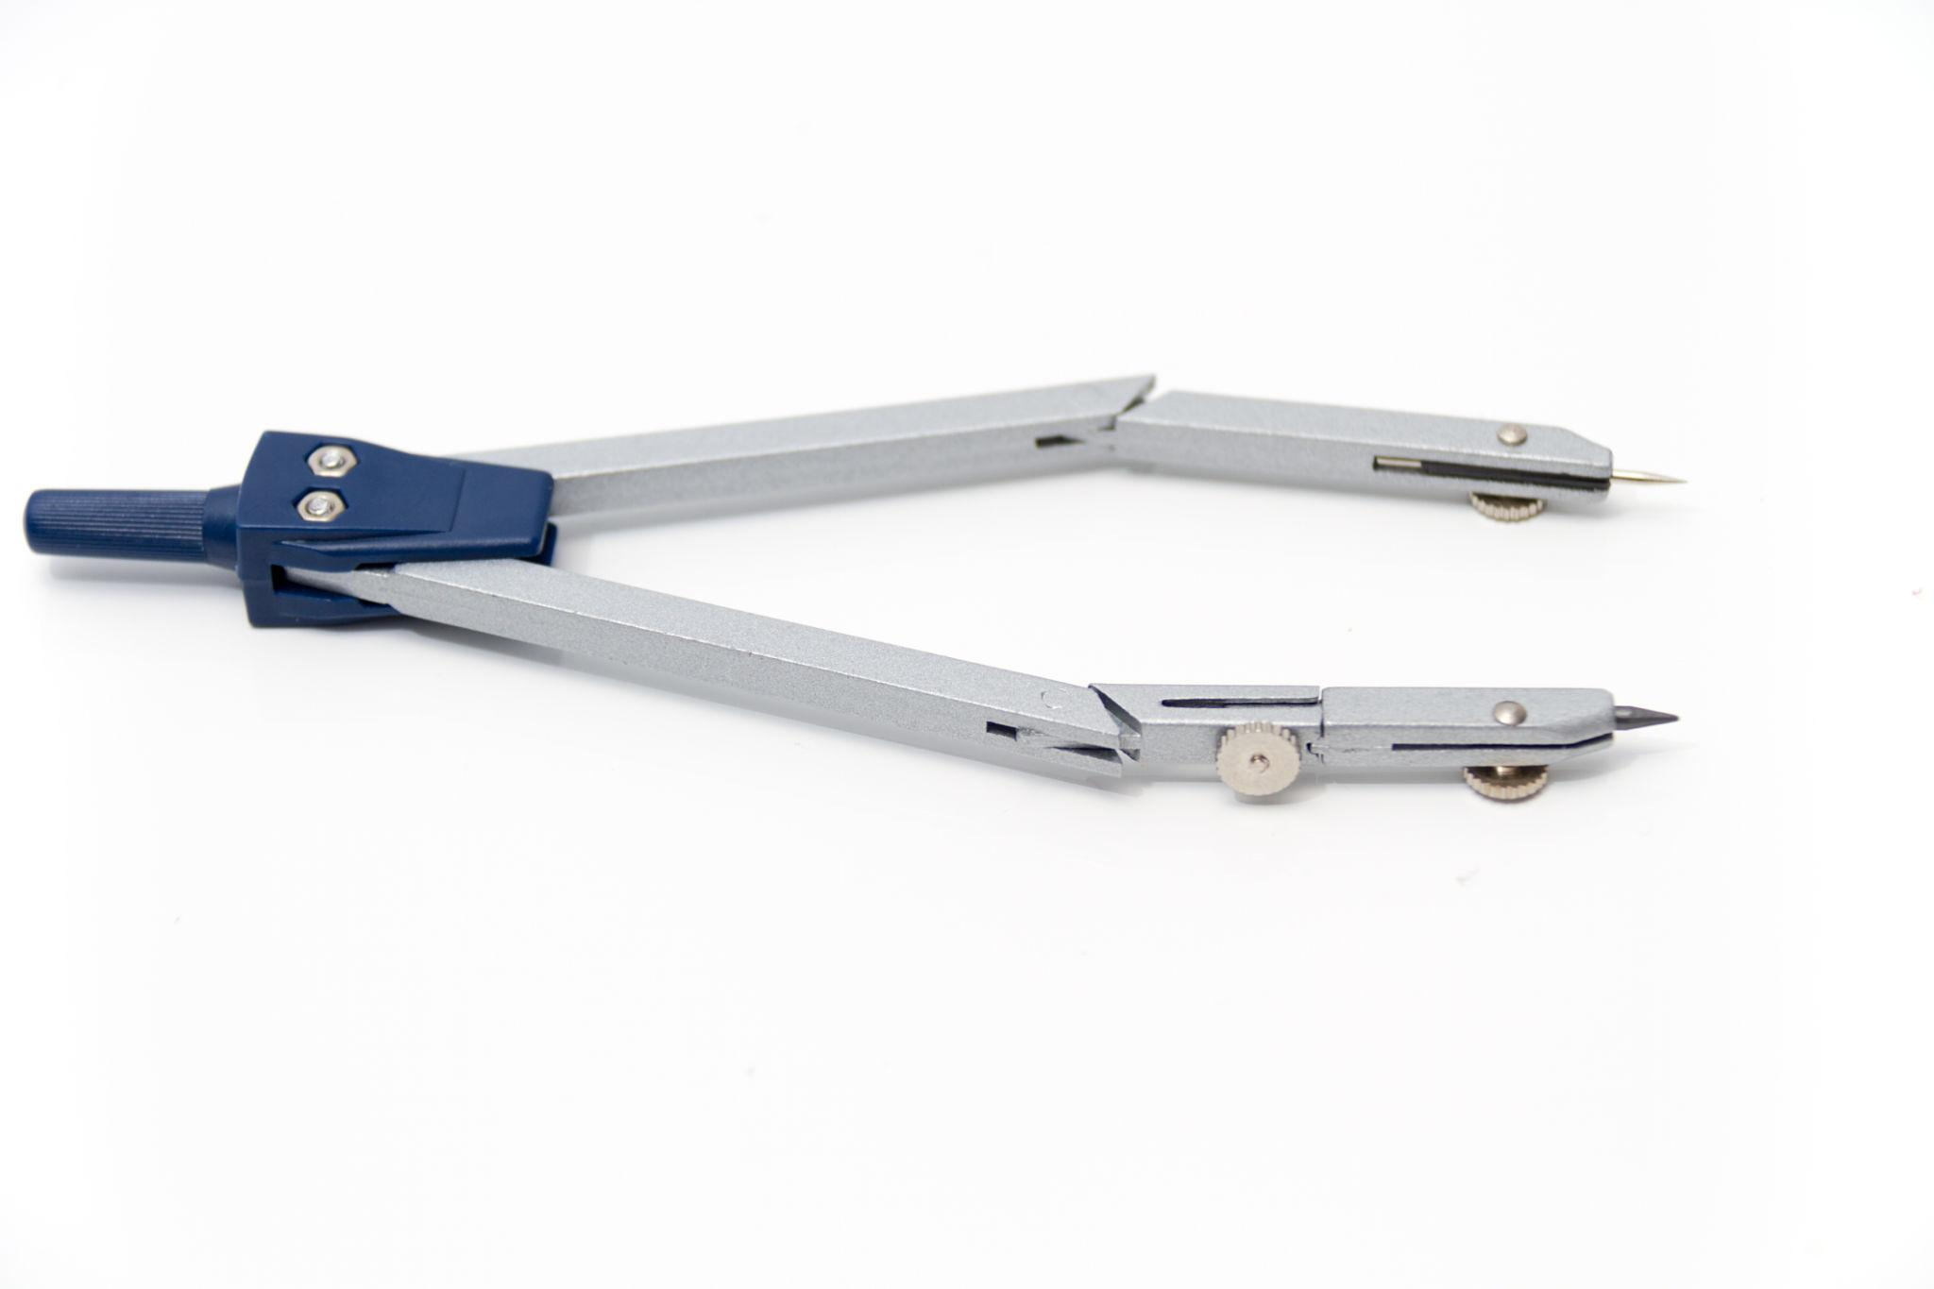

Set Square
# Source: AI Source: Provided by: [Data Path: Persons Table -> ID Column: 1, Name_En Column: Motasem Essam] -> From: [ChatGPT] on [7/25/2026]
Used to construct perpendicular and specified-angle lines and projection guides.
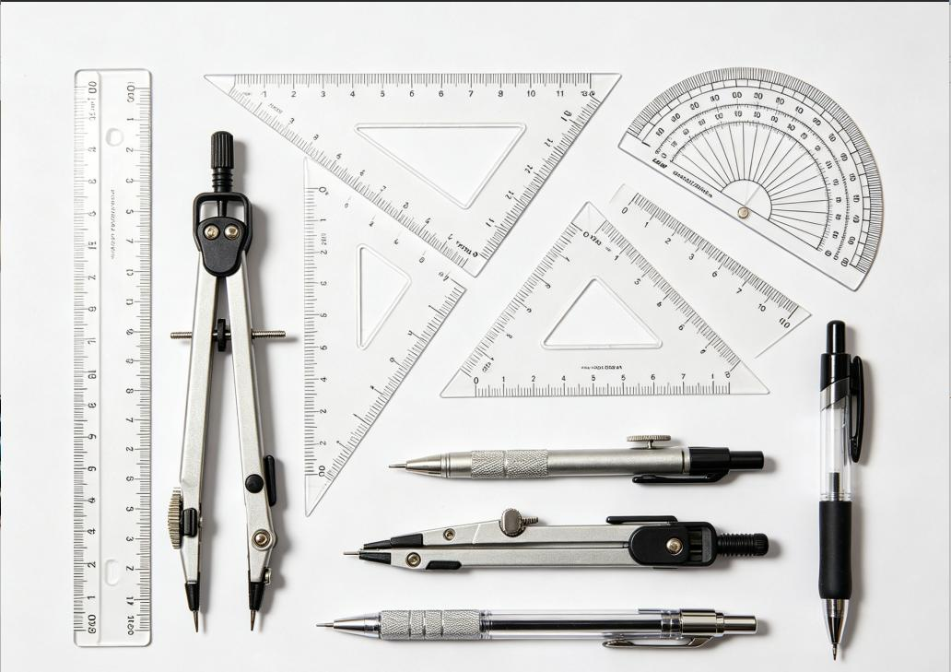

Protractor
# Source: AI Source: Provided by: [Data Path: Persons Table -> ID Column: 1, Name_En Column: Motasem Essam] -> From: [ChatGPT] on [7/25/2026]
Used to construct or verify angles that determine the direction of construction lines.
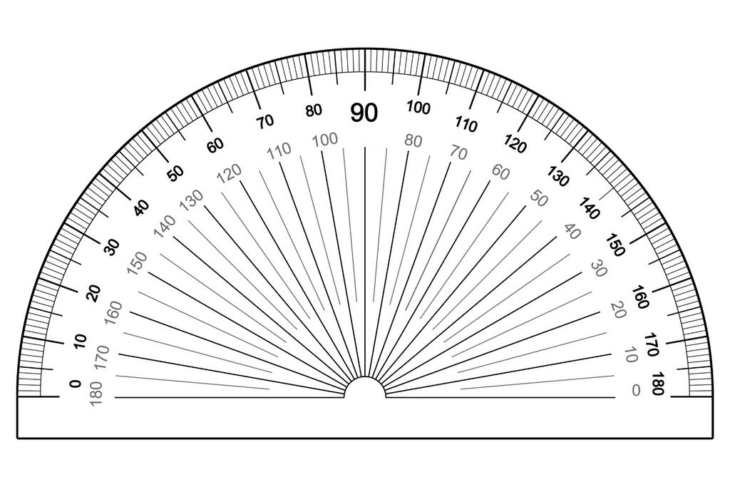

Dividers
# Source: AI Source: Provided by: [Data Path: Persons Table -> ID Column: 1, Name_En Column: Motasem Essam] -> From: [ChatGPT] on [7/25/2026]
Used to transfer distances and compare lengths between geometric elements.
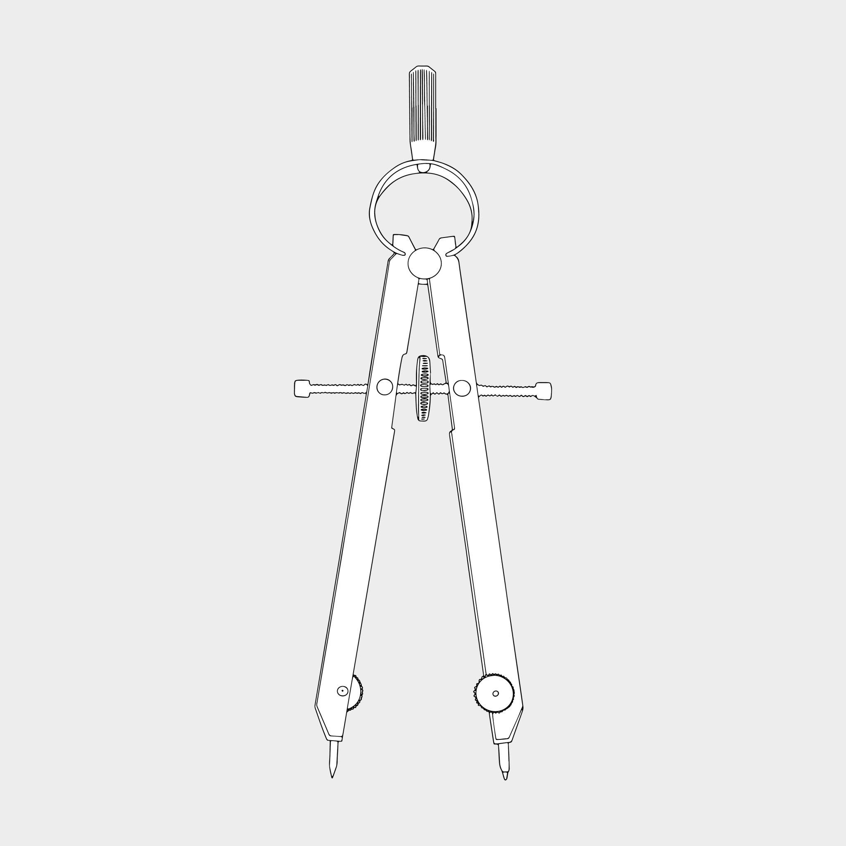

Fundamental Instrument-Based Construction Procedures

Constructing a Point by Line Intersection
# Source: AI Source: Provided by: [Data Path: Persons Table -> ID Column: 1, Name_En Column: Motasem Essam] -> From: [ChatGPT] on [7/25/2026]
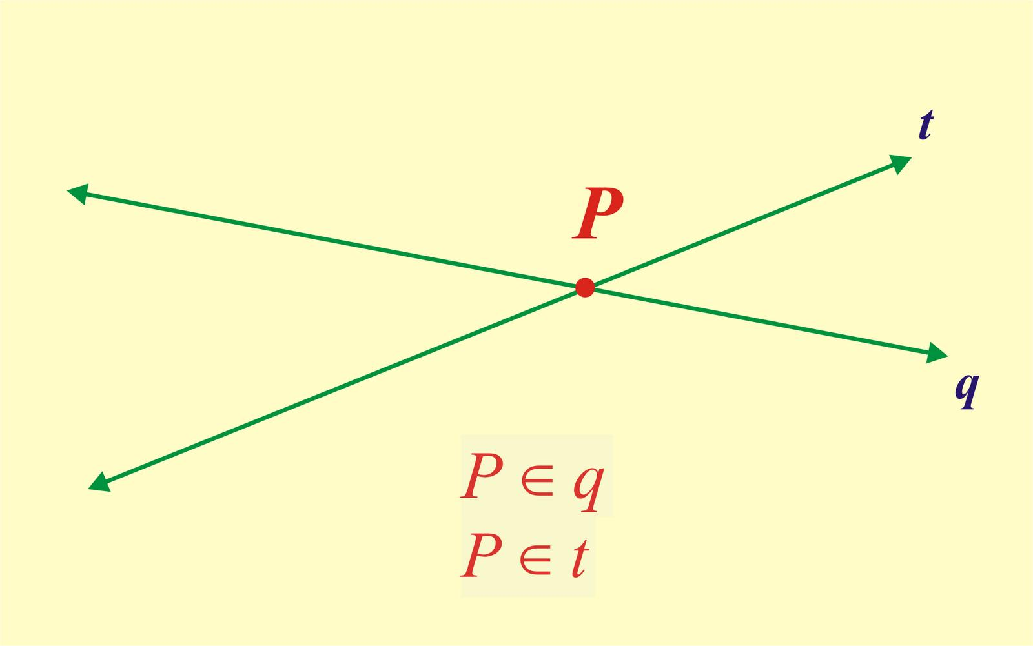
Procedure:
- Draw the first straight line using a straightedge.
- Draw the second straight line so that it intersects the first.
- Mark their intersection.
- Label the resulting point $P$.
The intersection determines a unique point when the two lines are distinct and non-parallel.

Constructing a Point by Circle Intersection
# Source: AI Source: Provided by: [Data Path: Persons Table -> ID Column: 1, Name_En Column: Motasem Essam] -> From: [ChatGPT] on [7/25/2026]
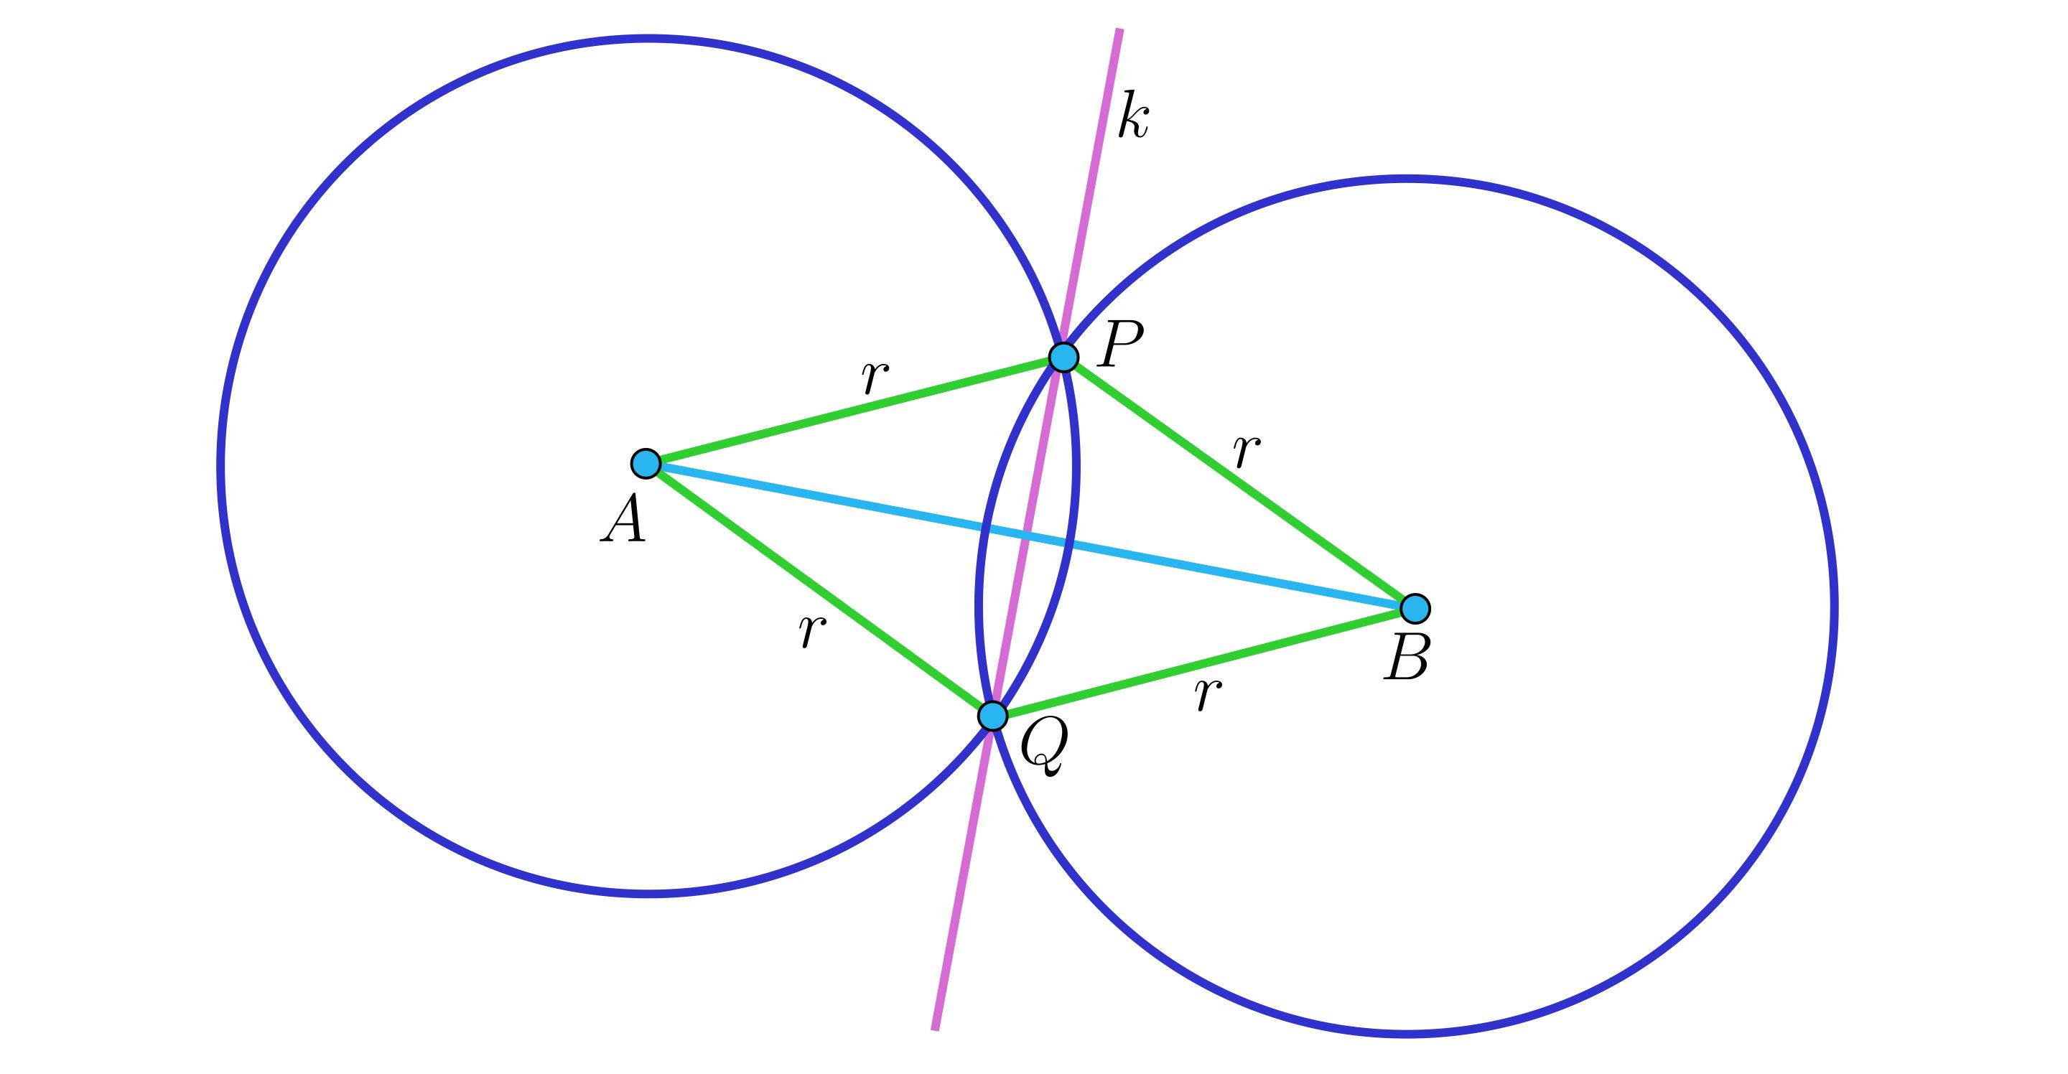
Procedure:
- Select two given centers.
- Use a compass to draw an arc or circle around each center.
- Adjust the radii according to the construction requirements.
- Identify the intersection of the two circles.
- Mark and label the resulting point.
Two distinct circles can have zero, one, or two intersection points.

Constructing a Midpoint
# Source: AI Source: Provided by: [Data Path: Persons Table -> ID Column: 1, Name_En Column: Motasem Essam] -> From: [ChatGPT] on [7/25/2026]
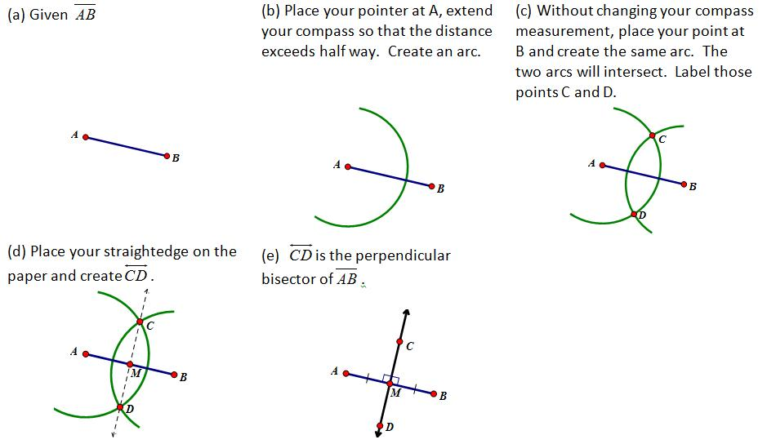
Procedure:
- Draw the given line segment $AB$.
- Open the compass to a radius greater than half the segment length.
- Draw arcs centered at $A$ and $B$, above and below the segment.
- Connect the two arc intersection points using a straightedge.
- Mark the intersection of this line with $AB$ as midpoint $M$.
The midpoint satisfies:
$$AM=MB$$

Constructing a Point by Projection
# Source: AI Source: Provided by: [Data Path: Persons Table -> ID Column: 1, Name_En Column: Motasem Essam] -> From: [ChatGPT] on [7/25/2026]
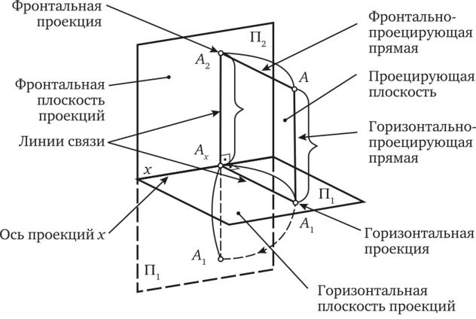
Procedure:
- Establish the horizontal and vertical projection planes.
- Represent the given spatial point in the required view.
- Draw projection lines perpendicular to the reference line.
- Transfer the corresponding projection using a straightedge and appropriate drawing instruments.
- Mark the resulting projected point in each view.
The corresponding projections represent the same spatial point.

Relationships Between Points and Other Geometric Objects
# Source: AI Source: Provided by: [Data Path: Persons Table -> ID Column: 1, Name_En Column: Motasem Essam] -> From: [ChatGPT] on [7/25/2026]
A point can define or participate in many geometric relationships.
- Point and Line: Two distinct points determine a unique straight line in Euclidean geometry.
- Point and Plane: Three non-collinear points determine a unique plane.
- Point and Sphere: A point's distance from the sphere's center determines whether it is inside, on, or outside the sphere.
- Point and Solid: A point may lie in the interior, on the boundary, or in the exterior of a solid.
For a sphere with center $C$ and radius $r$, let $d$ be the distance from $C$ to a point $P$:
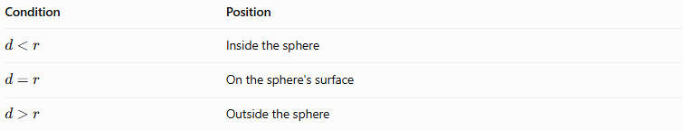
Condition | Position
$$d<r$$ | Inside the sphere
$$d=r$$ | On the sphere's surface
$$d>r$$ | Outside the sphere

Point vs. Other Geometric Elements
# Source: AI Source: Provided by: [Data Path: Persons Table -> ID Column: 1, Name_En Column: Motasem Essam] -> From: [ChatGPT] on [7/25/2026]
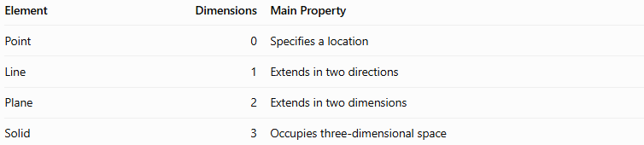
Element | Dimensions | Main Property
Point | 0 | Specifies a location
Line | 1 | Extends in two directions
Plane | 2 | Extends in two dimensions
Solid | 3 | Occupies three-dimensional space

Applications
# Source: AI Source: Provided by: [Data Path: Persons Table -> ID Column: 1, Name_En Column: Motasem Essam] -> From: [ChatGPT] on [7/25/2026]
Points are fundamental to:
- Coordinate Geometry: Describing exact locations with coordinates.
- Three-Dimensional Modeling: Defining vertices and positions in 3D models.
- Architecture and Engineering: Specifying locations of corners, components, and reference positions.
- Computer Graphics: Representing positions of objects and points in virtual scenes.
- Spatial Measurement: Calculating distances and locating objects in space.

Key Points
# Source: AI Source: Provided by: [Data Path: Persons Table -> ID Column: 1, Name_En Column: Motasem Essam] -> From: [ChatGPT] on [7/25/2026]
- A point represents an exact location and has no dimensions.
- In three-dimensional space, a point is commonly represented by three coordinates: $\left(x,y,z\right)$.
- A point may lie on a line, on a plane, inside a solid, on its surface, or outside it.
- Two distinct points determine a unique straight line.
- The distance between two points in three-dimensional space is calculated using the 3D distance formula.

Conclusion
# Source: AI Source: Provided by: [Data Path: Persons Table -> ID Column: 1, Name_En Column: Motasem Essam] -> From: [ChatGPT] on [7/25/2026]
A Point in Solid Geometry is a fundamental, dimensionless geometric element used to identify locations in three-dimensional space. Points form the foundation for defining lines, planes, vertices, and spatial relationships. Their coordinates allow geometric positions to be represented mathematically, while distance formulas help measure the separation between locations.

